Name- Akash Bhardwaj

Reg No-11019210034

Class -B.Tech CSE-C (DSAI)

**Experiment -2**

1. Write a program to display the elements of an array.

Program

#include <stdio.h>

void main()

{int n,item;

printf("Enter the size of array ");

scanf("%d",&n);

int arr[n];

for(int i=0;i<n;i++)

{printf("Enter the value of arr[%d] ",i);

scanf("%d",&item);

arr[i]=item;

}printf("The array is \n");

for(int i=0;i<n;i++)

{

printf("arr[%d]=%d ",i,arr[i]);

}}

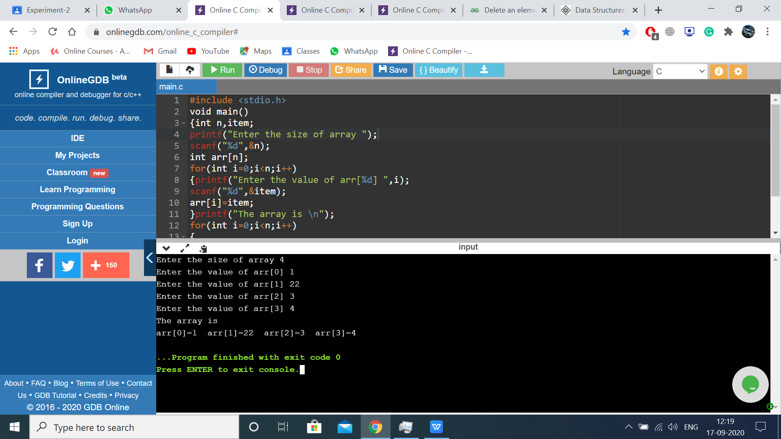

1. Write a program to insert elements of an array.

Program

#include <stdio.h>

void main()

{int n,item,a,insert;

printf("Enter the size of array ");

scanf("%d",&n);

int arr[n];

for(int i=0;i<n;i++){

printf("Enter the value of arr[%d] ",i);

scanf("%d",&item);

arr[i]=item;

}printf("The array is \n");

for(int i=0;i<n;i++){

printf("arr[%d]=%d ",i,arr[i]);

}

printf("Enter the positon of where you want to insert");

scanf("%d",&a);

printf("\n Enter the value of which you want to insert");

scanf("%d",&insert);

arr[a]=insert;

printf("The array after insertion is \n");

for(int i=0;i<n;i++){

printf("arr[%d]=%d ",i,arr[i]);

}}

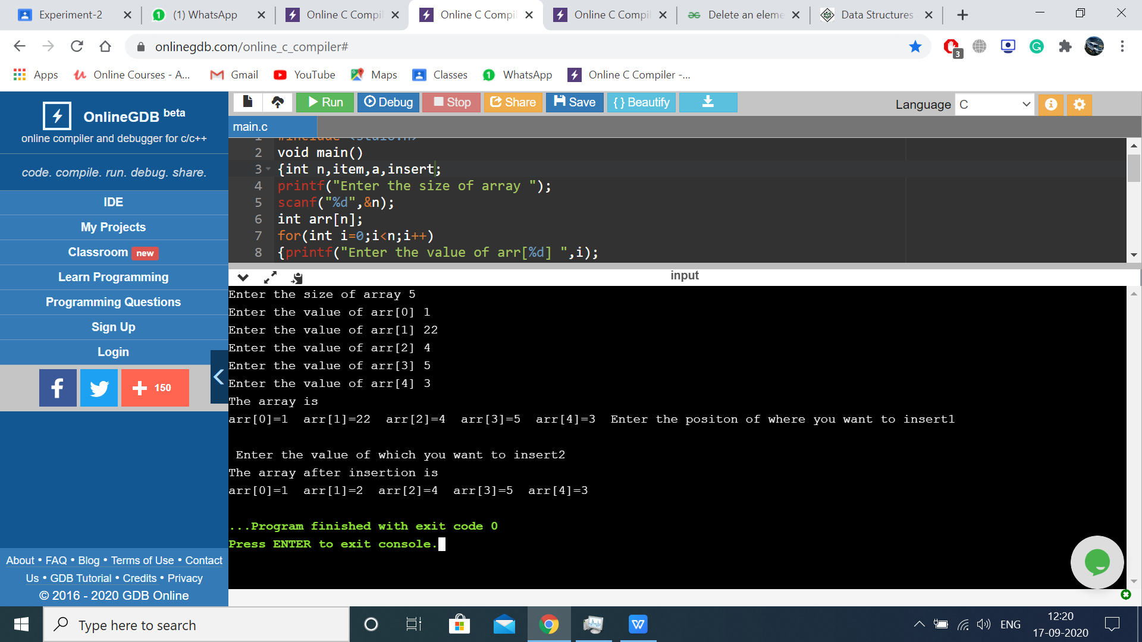

1. Write a program to delete elements of an array.

Program

#include <stdio.h>

void main()

{int i,n,item,d,p;

printf("Enter the size of array ");

scanf("%d",&n);

int arr[n];

for(i=0;i<n;i++){

printf("Enter the value of arr[%d] ",i);

scanf("%d",&item);

arr[i]=item;

}printf("The array is \n");

for(i=0;i<n;i++){

printf("arr[%d]=%d ",i,arr[i]);

}

printf("\n Enter the elemnt of which you want to delete ");

scanf("%d",&d);

for(i=0;i<n;i++){

if(arr[i]==d)

{p=i;}}

printf("The array after deletion is \n");

for(i=p+1;i<n;i++)

arr[i-1] = arr[i];

for(i=0;i<n-1;i++){

printf("arr[%d]=%d ",i,arr[i]);

}}

